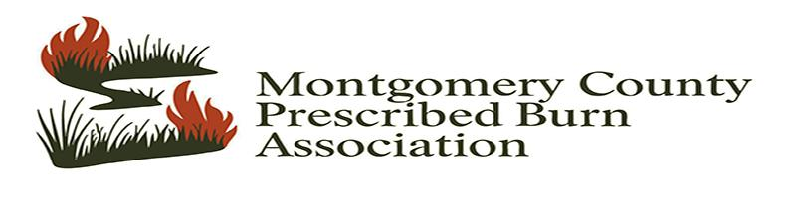
About Us
Prescribed Burn Associations (PBAs) are formed to overcome recurring limitations in implementing prescribed fire: adequate knowledge, training, experience, equipment, and people available to assist on a prescribed burn. The associations are equipped with proper burn equipment and operate on a neighbor-helping-neighbor system to assist members with prescribed burns.
Newly formed in September 2025, The Montgomery County Prescribed Burn Association (MCPBA) aims to overcome those issues in the Montgomery County area and into surrounding Illinois counties. The geography of the MCPBA is focused to stay within Montgomery County, but ultimately it is dictated by the distance members are willing to travel to assist on burns and members located outside Montgomery County, Illinois may be approved on a case by case basis.
Whether you need help applying prescribed fire to manage your land or want to gain hands-on experience, the Association is here to help!

Membership Criteria to Receive Assistance
Pay an annual $100 landowner membership fee or $50 Associate Membership fee (definitions of membership levels can be found in our PBA Bylaws); have once completed a wildland or prescribed fire training course as outlined in our PBA Member Guidelines Document; and assist with 2 PBA burns of another member per year OR assist one PBA burn of another member and attend one burn training per year.
Contact
You may submit the completed Membership form by scanning it and emailing it to:
MontgomeryCoPBA@gmail.com. Or you can access the Online membership form linked here. However, feel free to reach out to our Board members for more information.

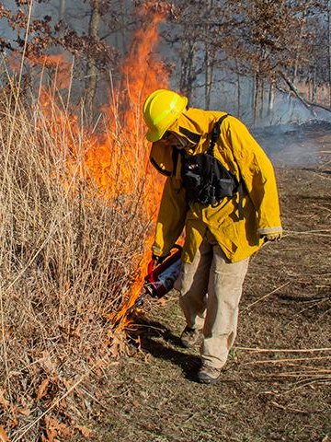
President: Nathan Hemken
Phone: 217-556-1620
Email: nathan1155@yahoo.com
Treasurer: Kate Whitlock
Phone: 618-656-9394
Email: katebwatts@gmail.com

Secretary: Bob Fromm
Phone 217-652-0280
Email: wattsfrommfamilyfarm@gmail.com

Montgomery County PBA Membership Form

NAME: _________________________ ________

PHONE _________________________________(mobile preferred for texting)

EMAIL _________________________ ________

MAILING ADDRESS ___________________________________________________________________________

PROPERTY LOCATION (if not your home address)

________________________________________________________________________________________

BACKGROUND
Give us a brief description of your experience and training with prescribed burning, the type of land you would like to manage with prescribed burning (woodland, savanna, or grassland), goals for your land management, or anything else you’d like to share with us in the space below.
________________________________________________________________________________________________________________________________________________________________________________________________________________________________________________________________________________________________________________________________________________________________________________________________________________________________________________________________________________________________________________________________________________________________________________________________________________________________________________________________________________________________________________________________________________________________________________________________________________________________________________________________
Circle your membership level:
Landowner - $100 Associate- $50 Volunteer - Donation Based
Dues may be made out to Montgomery County PBA and mailed to:
Name: Kate Whitlock-Watts
Address: 8392 Crabtree Trl, Litchfield, IL 62056
Scan the qr code below or use the pay now button when completing form online. Copy this url for downloaded copies of form.
https://www.paypal.com/ncp/payment/9KWGP2VRH73HJ
